Mar Hall

  - Guest Activity Options

Options
Falconry 1
4 x 4 Driving 2
Clay pigeon shooting 3
Horse Riding 3
Distillery / Whisky Experience 4
Hillwalking 5
Helicopter flights ……………………………6

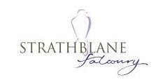
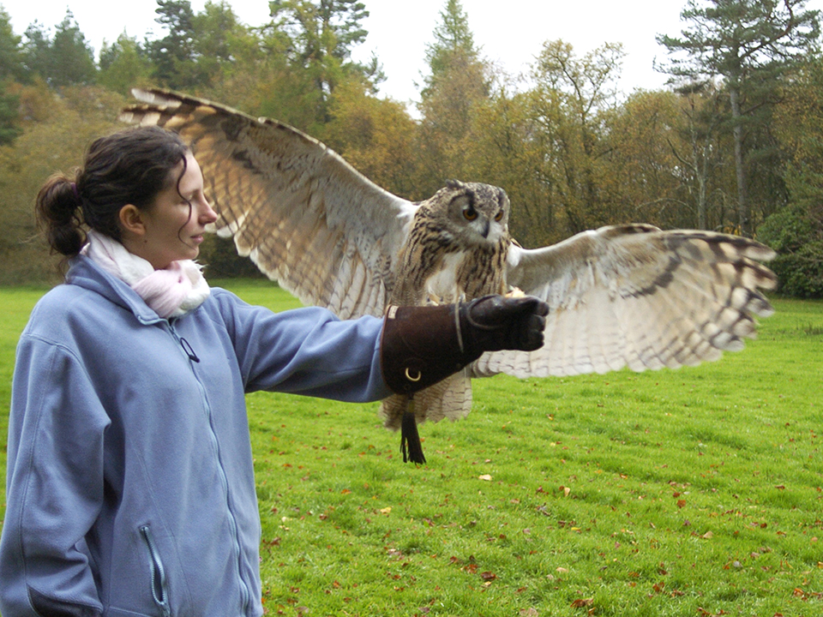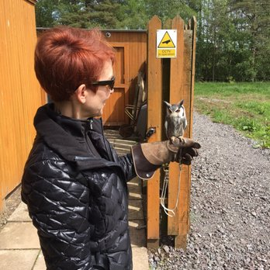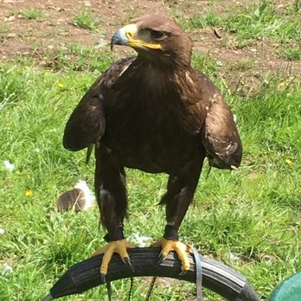

In association with the team at Strathblane Falconry we can offer sessions for individuals, couples, families or large corporate groups.

Prices and availability on request

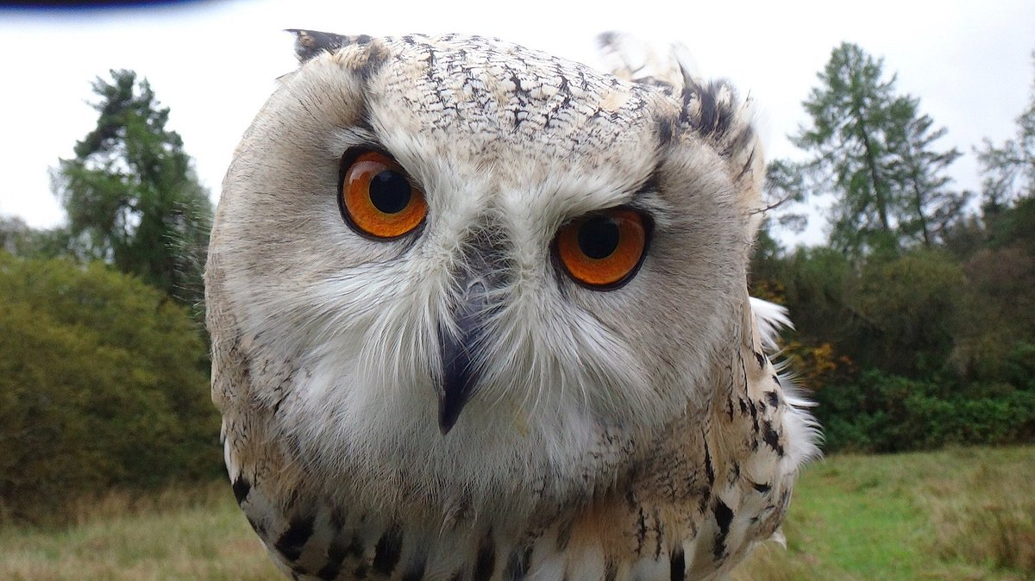

Are you a petrolhead who would like to get into the local hillsides. Why not combine the two by doing some off-roading and driving a Landrover Defender to a local hilltop.
This experience is available for individuals, families and corporate groups. Hilltop dining is available from a picnic or bbq to a fine dining meal.
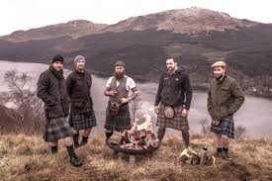

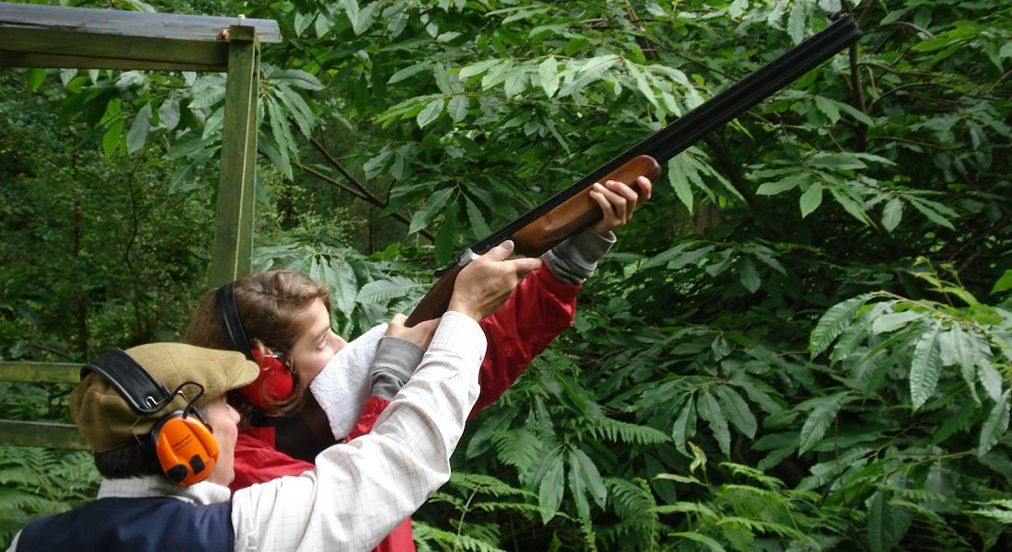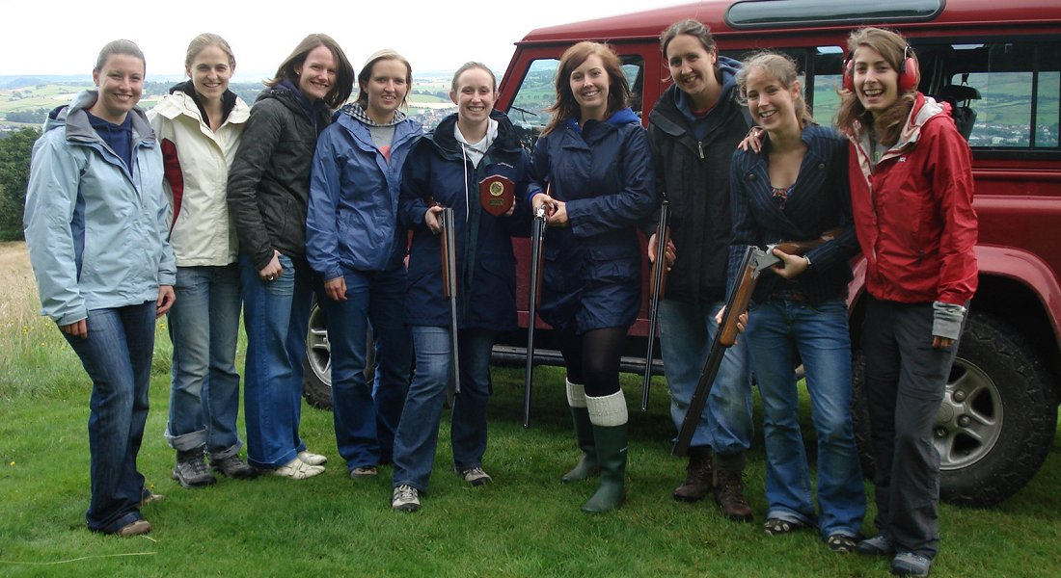

A short drive from us is Loch Lomond Shooting School who offer Clay pigeon shooting (12 years and above) or air rifle and archery for all the family. If you have no personal transport, collection from the main entrance to Mar Hall is available at a small additional cost.
Why not get the most from your visit? Combine any 3 events to maximise your experience!
On the same site is Loch Lomond Pony Trekking should you prefer something a bit more leisurely.

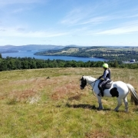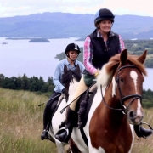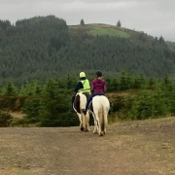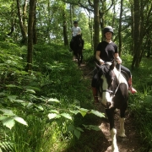

Whisky and gin experiences are available. Whether it is on site here at Mar Hall for corporate or large groups or visiting one of our many local distilleries.

Soime options are:

- Master blender. Blend and create your own single malt.
- Whisky and chocolate matching.
- Warehouse tasting tours (off site only)
- Gin blending
- Gin distilling school (off site only)
- Fine and rare tasting
- Simple whisky tasting
- For events a “whisky” haggis address is available

For our more energetic visitors who may like to go “Munro bagging” whilst in Scotland our concierge team can advise on local walks of varied difficulty levels or arrange for a guided walk.
A rock climbing guide/instructor is also available for the andrenaline junkies amongst us.

Prices are available on request.
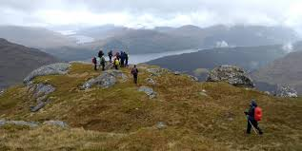
Heli- Dine packages. Could also package up with an overnight. Oscar & Charlie from Heli-Air keen to come and see us with a view to signing up to heli-dine. Possible pleasure/sightseeing offering as an activity. Sky-high proposals? Lots of possibilities.

Charlie will let us know about the cost of a wind sock. That pretty much gives everyone the impression that there is potential for aircraft to come and go and may ask even if there is no helicopter on site at that moment.

